Task 1
The code for producing the plot is in its own script file task1.m
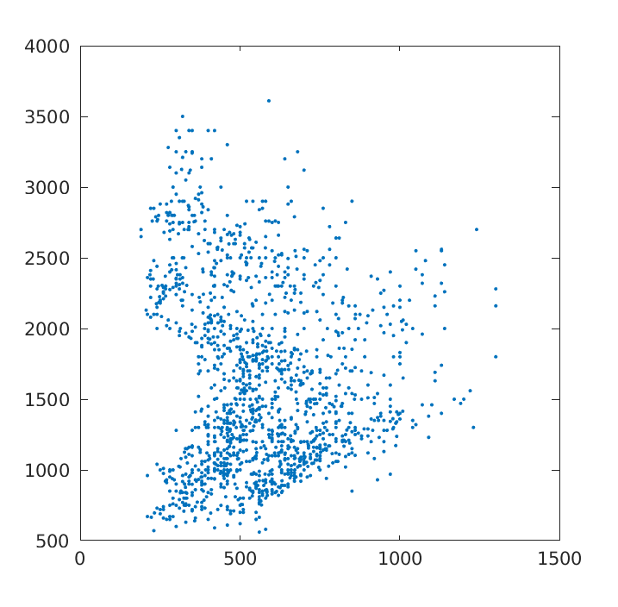

Task 2

